About RFS

About RFS
In this lecture let’s discuss about the Root File System(RFS) and its directory structure.
Later videos in this course will show you how you can create your own root file system by using busybox and buildroot and we can also test it on the hardware.
Now the root file system, as the name indicates, it’s a file system which Linux mounts to the "/" (root)
File system is nothing but a collection of files organized in standard folder structure.
Yes!!! There is a standard for the Linux file system. That is called "File system Hierarchy Standard"

You may have to check this document if you are interested.
https://wiki.Linuxfoundation.org/lsb/fhs-30
https://en.wikipedia.org/wiki/File system_Hierarchy_Standard#cite_note-2
In a typical file system you will find the below folder structure, even though all these folders are not required for Linux to boot and mount the file system successfully.
Now, let’s understand what the purpose of each folder is and what exactly it contains.
The official documentation of the FHS says this about the directories present in the "/"
http://refspecs.Linuxfoundation.org/FHS_3.0/fhs/ch03s02.html
Directory | Description
bin | Essential command binaries
boot | Static files of the boot loader
dev | Device files
etc | Host-specific system configuration
lib | Essential shared libraries and kernel modules
media | Mount point for removable media
mnt | Mount point for mounting a file system temporarily
opt | Add-on application software packages
run | Data relevant to running processes
sbin | Essential system binaries
srv | Data for services provided by this system
tmp | Temporary files
usr | Secondary hierarchy
var | Variable data

bin/ :
This directory contains binaries of Linux commands which are used by both the system admins and users.
You don’t need privileges from your System admin to execute these commands neither you need root access. Remember that this folder will not contain binaries for all the Linux commands. There is a restriction on what types of commands have to be placed in this directory, because these binaries can be executed by the common user.
Below are some the commands you will find it in the bin/ directory.
cat Utility to concatenate files to standard output
chgrp Utility to change file group ownership
chmod Utility to change file access permissions
chown Utility to change file owner and group
cp Utility to copy files and directories
date Utility to print or set the system data and time
dd Utility to convert and copy a file
df Utility to report file system disk space usage
dmesg Utility to print or control the kernel message buffer
echo Utility to display a line of text
false Utility to do nothing, unsuccessfully
hostname Utility to show or set the system's host name
kill Utility to send signals to processes
ln Utility to make links between files
login Utility to begin a session on the system
ls Utility to list directory contents
mkdir Utility to make directories
mknod Utility to make block or character special files
more Utility to page through text
mount Utility to mount a file system
mv Utility to move/rename files
ps Utility to report process status
pwd Utility to print name of current working directory
you can see that commands related to "repairing", "recovering", "restoring", "network configuration" ,”modules install remove” are not found in this directory.

boot/:
This directory contains the boot related files, which are required to boot the Linux. This directory may be read by the boot loader to read the boot images like Linux kernel image, dtb, vmLinux, initramfs, etc.
So this directory may be accessed by boot loader even before the kernel boots and mounts the file system.

dev/:
This is the place where you can find the "device files”.
You may be heard or read this statement "in unix/Linux devices are treated like file access" .
Yes, if you want to access any i/o, networking devices, memory devices, serial devices, parallel devices, input output devices such as keyboard, mouse, display, everything will be treated like a file.
So, this directory will have the file entry for every device
For example: the i2c devices may have a file entries like this
/dev/i2c-0 ,
/dev/i2c-1,
The user Space application can use this device files to access those devices .
The ram may have a device file entry like /dev/ram0
The 2 partitions of the SD card may have entries like this:
/dev/mmcblk0p1
/dev/mmcblkop2.
The serial devices may have entries like this:
/dev/ttyS0,
/dev/ttyS1,
/dev/ttyO0
It’s the responsibility of the respective drivers to populate this directory with the device files

etc/ :
This is the place where all the start-up scripts, networking scripts, scripts to start and stop networking protocols like NFS, networking configuration files, different run level scripts will be stored.
1) Contains run level scripts, which will be used during different run levels
2) Contains start-up and shutdown scripts
3) Contains various scripts related to services like start/stop networking, start/stop NFS, etc
4) Contains various configuration files, like passwd, hostinfo, etc.
5) Contains various network configuration files

lib/ :
The major contents of this directory are
1) The dynamically loadable kernel modules. ( later you will see, when we compile the kernel modules and when we run “modules install” command , all the kernel modules will go and sit in this directory under the sub directory "modules" .)
2) To store the Essential shared libraries (.so.*) for dynamic linking.
for example, 'C' shared library(libc), math library, python libray, etc,

media/ :
This is the mount point for the removable media like your USB flash drive, SD cards, camera, cell phone memory, etc .
For example, when i connect my SD card to the PC, there will be 2 device files will be created for each partition 1) /dev/sdb1 and 2) /dev/sdb2
and theses 2 device files are automatically mounted under the /media directory. So that i can access those 2 partitions just like folders.
Some examples:-
/media/cdrom for CD-ROM
/media/<your usb flash drive name>

mnt/ :
This is the place where you can mount the temporary file system.
The system admins can use a Linux commands to temporarily mount and un-mount the file system, if they want to transfer any file.

opt/ :
"opt" stands for "optional"
This directory will be used when you install any software packages for your Linux distribution.
For example if i run the command apt-get install <some packages name> then the package will be installed in this directory.

sbin/ :
The commands which come in the category of system administration will be stored in this directory, which is used by your sys admins for the purpose of networking configurations, repairing, restoring and recovering .
may be sbin stands for "System Admin's bin" ??
It also has root only command and need privileges to execute those commands.
These are the commands which you will find in sbin/
Command | Description
fastboot | Reboot the system without checking the disks (optional)
fasthalt | Stop the system without checking the disks (optional)
fdisk | Partition table manipulator (optional)
fsck | File system check and repair utility (optional)
fsck.* | File system check and repair utility for a specific file system (optional)
getty | The getty program (optional)
halt | Command to stop the system (optional)
ifconfig | Configure a network interface (optional)
init | Initial process (optional)
mkfs | Command to build a file system (optional)
mkfs.* | Command to build a specific file system (optional)
mkswap | Command to set up a swap area (optional)
reboot | Command to reboot the system (optional)
route | IP routing table utility (optional)
swapon | Enable paging and swapping (optional)
swapoff | Disable paging and swapping (optional)
update | Daemon to periodically flush file system buffers (optional)

home/:
The /home directory contains a home folder for each user.
Each user only has write access to their own home folder and must obtain elevated permissions (become the root user) to modify other files on the system.
This directory will be used to store personal data of the user .
In a single user mode you may have folder like this
/home/ramesh
In a multiple user mode, you may have folder dedicated to each user.
/home/ramesh, /home/suresh, /home/ram etc.

srv/ :
SRV stands for "Service"
The /srv directory contains “data for services provided by the system.” If you are using the Apache HTTP server to serve a website, you’d likely store your website’s files in a directory inside the /srv directory.

tmp/ :
Applications store temporary files in the /tmp directory.

usr/ :
According to FHS, it’s a "secondary hierarchy", the usr/ directory may contain the below sub directories
Directory Description
bin Most user commands
include Header files included by C programs
lib Libraries
local Local hierarchy (empty after main installation)
sbin Non-vital system binaries
share Architecture-independent data
/usr/bin contains binary of the commands for user programs
For example, if you have firefox on your system then just check it must be available under "/usr/bin" not under /bin. Because it is a binary related to user installed programs, similarly, "zip" command also you will find it under /usr/bin.
/usr/sbin contains, again privileged commands which may be used by the system admins, but these commands are for system administration purposes.
/usr/include will hold the header files which will be included from the C programs you write.
/usb/lib will again hold the shared libraries, linker/loader files , which enable your /usb/bin and /usr/sbin commands to execute.
For more information you may check this official link:
http://refspecs.linuxfoundation.org/FHS_3.0/fhs/ch03.html

Generating "initramfs" using RFS

About initramfs and creating initramfs
What is initramfs ?
The word "initramfs" is made up of three words "initial" "RAM based" "file system"
This is nothing but a file system hierarchy (which you just studied in the last lecture, all those directory structure), made to live in the RAM of the device by compressing it (we use compression because RAM is precious, we cannot use whole RAM just to store the FS) and during booting, Linux mounts this file system as the initial file system. That means you just need RAM to mount the FS and get going with the complete boot Process.
Does that mean usage of initramfs is compulsory? Used everywhere, every time ?
No, not necessarily. Using initramfs is optional.
So, why do we need initramfs ?
Let’s understand this with an example.
Let’s say you have a product and your product has USB interfaces, mass storage devices like SD card and let’s say you also have networking peripherals like Ethernet and also display.
Now, to operate this wide range of peripherals, all the device drivers must be in place right?
That means all the drivers must be loaded in to the kernel space.
And along with the drivers, some peripherals may require the firmware binaries to operate.
One idea is make sure that all those drivers are “built in” in to the kernel, that’s not a great idea because that makes your Linux kernel specific to your product and it will drastically increase the Linux kernel image size.
Another good way is, you come up with the minimal file system, where you store all your drivers and firmware, and load that FS in to the RAM and ask the Linux to mount that file system during boot( Thanks to kernel boot arguments , you can use the kernel boot arguments to indicate kernel that your FS resides in RAM )
When the kernel mounts that file system from RAM, it loads all the required drivers for your product and all the peripherals of your product are ready to operate, because the drivers are in place.
after That you can even get rid of this RAM based file system and use (switch to) some other advanced file system which resides on your other memory devices like eMMC/SD card or even you can mount from the network.
So, basically initramfs embedded into the kernel and loaded at an early stage of the boot process, where it gives all the minimal requirements to boot the Linux kernel successfully on the board just from RAM without worrying about other peripherals. And what you should store in initramfs is left to your product requirements, you may store all the important drivers and firmware, you may keep your product specific scripts, early graphic display logos, etc.
How to keep initramfs in to RAM?
There are 2 ways,
1) You can make initramfs “built in” in to the Linux Kernel during compilation ( i will show you later in this course) , so when the Linux starts booting , it will place the initramfs in the RAM and mounts as the initial root file system and continues.
2) You can load the initramfs from some other sources in to the RAM of your board and tell the Linux Kernel about it (that is , at what RAM address initramfs is present ) via the kernel boot arguments.
We will see both methods in this course as we make a progress!
How to generate the innitramfs ?
Follow these steps to generate the initramfs
Reproduce these steps at your desk, because we are going to use the generated initramfs in our course as we move along.
Step 1: Download and extract the root file system attached with this lecture. This root file system I took from TI software SDK
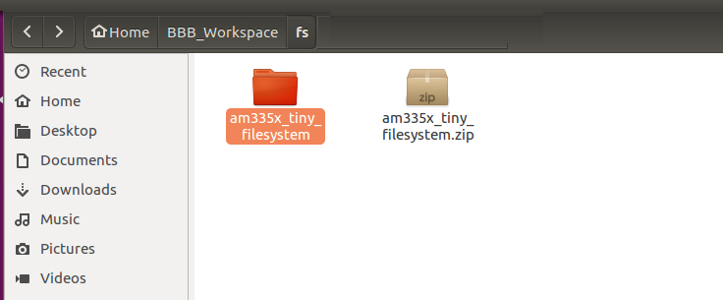

Step 2: Get in to the extracted folder and run the below 2 commands from the “terminal”
$ find . | cpio -H newc -o > ../initramfs.cpio
$ cat ../initramfs.cpio | gzip > ../initramfs.gz
In the first command we are generating a cpio archive and then gz archive.
Refer the image below.
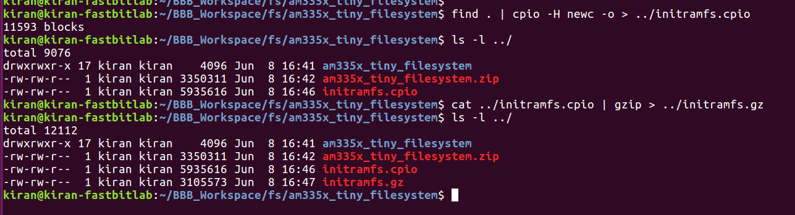
You will end up with the file “initramfs.gz” which is about 3MB.
STEP 3 : install mkImage command
For that run “apt-get install u-boot-tools” on your terminal software, this will install all the u-boot related tools along with mkImage tool.
$ apt-get install u-boot-tools
STEP 4: Make our initramfs , uboot friendly by attaching the uboot header with load address and other info .
Run the below command.
$ mkimage -A arm -O Linux -T ramdisk -C none -a 0x80800000 -n "Root Filesystem" -d ../initramfs.gz ../initramfs
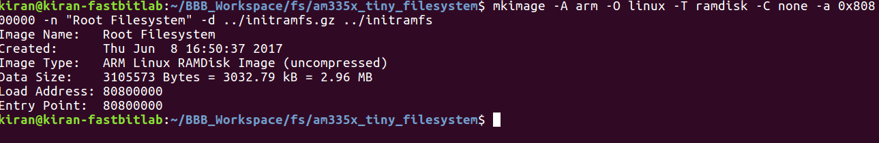
Great now you will end up with a file “initramfs” which also includes the uboot header and this file we will be used as ram based file system whenever required.

